Course Name:  Course Code: | Basic of Electrical Engineering Laboratory  316U06L102 | Semester: | I
Date of Performance: | / /20-- | Batch No:
Student Name: |  | Roll No:
Faculty Sign & Date: |  | Grade/Marks: | / 20

Experiment No: 2

Title: Thevenin’s Theorem

Aim and Objective of the Experiment:
- To Verify for Thevenin’s Theorem for the given circuit

COs to be achieved:
CO1: Analyze resistive DC networks using various network theorems.

Circuit Diagram:
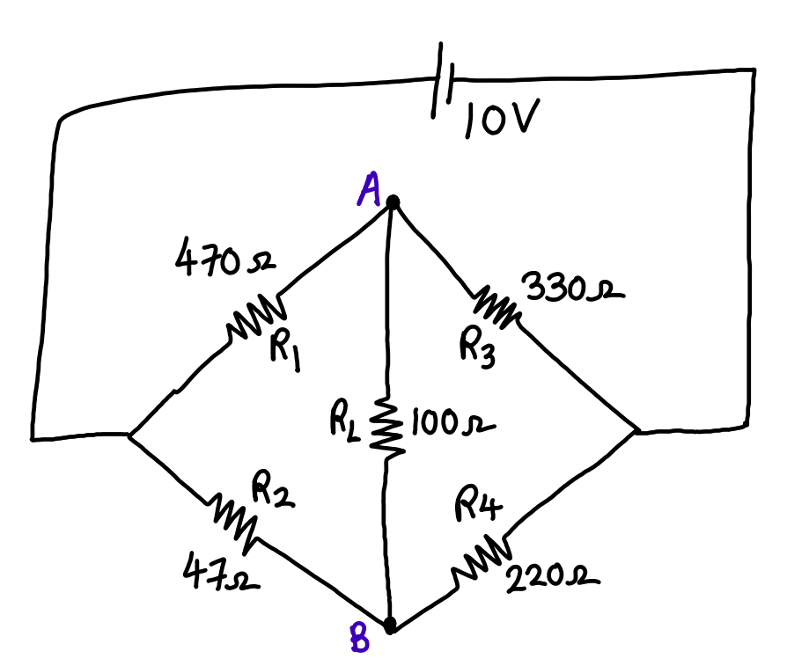

Task 1: Circuit Diagram to measure R_{TH}:

Task 2: Circuit Diagram to measure V_{TH:}

Task 3: Thevenin’s Equivalent circuit

Stepwise-Procedure:
Thevenin’s Theorem:

1. Connect the circuit as shown in the circuit diagram.
2. Set 10V and measure open circuit voltage V_{Th} across load terminals A and B.

3. Replace all voltage sources by Short circuit and measure R_{Th} across terminals A and B as per the circuit diagram shown in the figure.
4. Draw Thevenin’s equivalent circuit and determine the value of load current from it.
5. Verify the results theoretically.
Calculations:

Observation Table:
 | V_{TH} (V) | R_{TH}  (Ω) | I_{L} (mA)
Theoretical value

Practical value

Draw Thevenin’s Equivalent circuit

Post Lab Questions:
- State what is mean by linear network.

- State the different applications of linear network.

Conclusion:
Signature of faculty in-charge with Date:

